Machine Learning

Machine Learning is the field of study that gives computers the capability to learn without being explicitly programmed. Machine can learn itself from past data and automatically improve.
Machine Learning is a branch of artificial intelligence that develops algorithms by learning the hidden patterns of the datasets used it to make predictions on new similar type data, without being explicitly programmed for each task.
Machine Learning lifecycle:
1. Study the Problems: understanding the business problem and defining the objectives of the model.
2. Data Collection: we collect the relevant data required for the model from various sources such as databases, APIs, or web scraping.
3. Data Preparation: This can be done in the following steps:
- Data cleaning
- Data Transformation
- Explanatory Data Analysis
- Split the dataset for training and testing.
4. Model Selection: select the appropriate machine learning algorithm that is suitable for our problem.
5. Model building and Training: Train the model using the preprocessed dataset.
6. Model Evaluation: Once the model is trained, it can be evaluated on the test dataset to determine its accuracy and performance using different techniques like classification report, F1 score, precision, recall, ROC Curve.

Types of Machine Learning
- Supervised Machine Learning
- Unsupervised Machine Learning
- Reinforcement Machine Learning

1. Supervised Machine Learning:

This algorithm consists of a target/outcome variable (or dependent variable) which is to be predicted from a given set of predictors (independent variables). Using this set of variables, we generate a function that maps input data to desired outputs. The training process continues until the model achieves the desired level of accuracy on the training data.
- Regression,
- Decision Tree,
- Random Forest,
- KNN,
- Logistic Regression

Regression: Algorithm learns to predict continuous values based on input features. The output labels in regression are continuous values, such as stock prices, and housing prices.

Regression algorithms in ML are: Linear Regression, Polynomial Regression, Decision Tree Regression, Random Forest Regression, Support Vector Regression, Ridge Regression, etc.
Classification:

2. Unsupervised Machine Learning:

Unsupervised machine learning uses machine learning algorithms to analyze and cluster unlabeled datasets. These algorithms discover hidden patterns or data groupings without the need for human intervention.
customer segmentation, and image recognition.

- Linear Regression – supervised learning algorithm

Linear regression is a type of supervised machine learning algorithm that computes the linear relationship between a dependent variable and one or more independent features.
The goal of the algorithm is to find the best linear equation that can predict the value of the dependent variable based on the independent variables.

X = independent variable
Y = dependent or target variable

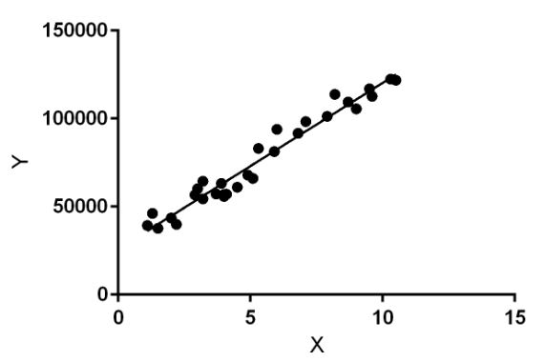

Linear regression performs the task to predict a dependent variable value (y) based on a given independent variable (x)).

Y_{i} = β₀ + β₁X_{i}
where Yi = Dependent variable, β0 = constant/Intercept, β1 = Slope/Intercept, Xi = Independent variable.
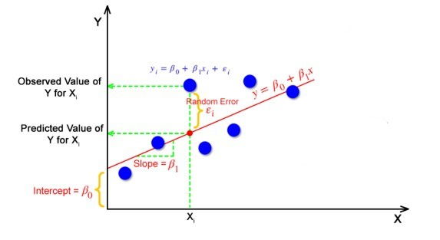
The best fit line is a line that has the least error which means the error between predicted values and actual values should be minimum.

Random Error(Residuals)
In regression, the difference between the observed value of the dependent variable(yi) and the predicted value(predicted) is called the residuals.
ε_{i} = y_{predicted} – y_{i}

Cost function
In Linear Regression, generally Mean Squared Error (MSE) cost function is used, which is the average of squared error that occurred between the ypredicted and yi.



- Logistic Regression -

Logistic regression is used for building machine learning models where the dependent variable is binary. It just means a variable that has only 2 outputs, True or False, 0 or 1 and yes or no. for example, A person will survive this accident or not, the student will pass this exam or not. The outcome can either be yes or no (2 outputs).

Logistic Function - sigmoid function ( S curved)

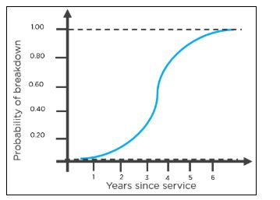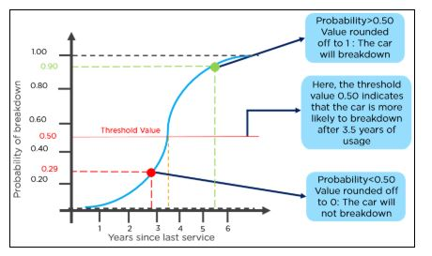

How Does the Logistic Regression Algorithm Work?

Ex, an organization wants to determine an employee’s salary increase based on their performance.

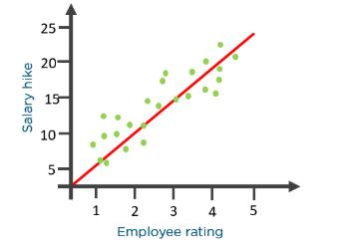
Plotting a regression line by considering the employee’s performance as the independent variable, and the salary increase as the dependent variable will make their task easier.

Now, what if the organization wants to know whether an employee would get a promotion or not based on their performance?
Based on the threshold values, the organization can decide whether an employee will get a salary increase or not.
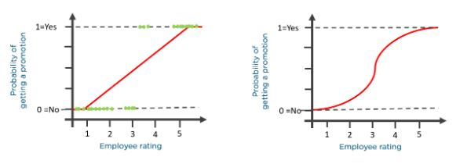

let’s go over the odds of success.
Odds (𝜃) = Probability of an event happening / Probability of an event not happening
𝜃 = p / 1 - p
The values of odds range from zero to ∞ and the value of probability lies between zero and one.

Consider the equation of a straight line:

𝑦 = 𝛽0 + 𝛽1* 𝑥
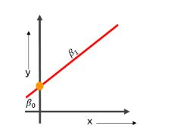
y is the value of the prediction

Now to predict the odds of success, we use the following formula:

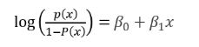
Exponentiating both the sides, we have:
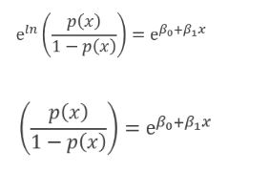
Let Y = e 𝛽0+𝛽1 * 𝑥 Then
p(x) / 1 - p(x) = Y
p(x) = Y(1 - p(x))
p(x) = Y - Y(p(x))
p(x) + Y(p(x)) = Y
p(x)(1+Y) = Y
p(x) = Y / 1+Y
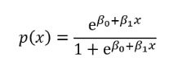
The equation of the sigmoid function is:
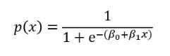
The sigmoid curve obtained from the above equation is as follows:
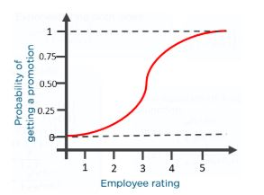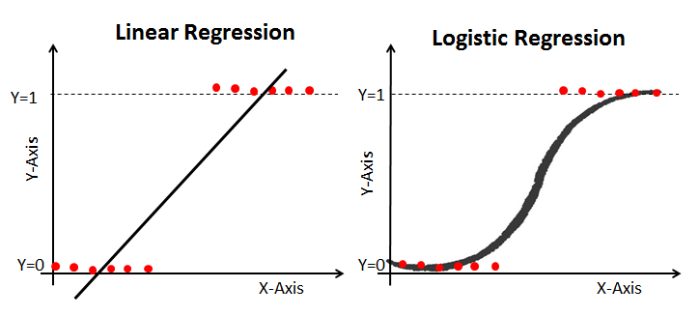

Types of Logistic Regression

Binomial Logistic regression: target variable can have only 2 possible types: “0” or “1”

# import the necessary libraries
from sklearn.datasets import load_breast_cancer
from sklearn.linear_model import LogisticRegression
from sklearn.model_selection import train_test_split
from sklearn.metrics import accuracy_score,confusion_matrix
# load the breast cancer dataset
X, y = load_breast_cancer(return_X_y=True)
# split the train and test dataset
X_train, X_test,\
y_train, y_test = train_test_split(X, y,
test_size=0.20,
random_state=23)
# LogisticRegression
clf = LogisticRegression(random_state=0)
clf.fit(X_train, y_train)
# Prediction
y_pred = clf.predict(X_test)

acc = accuracy_score(y_test, y_pred)
print("Logistic Regression model accuracy (in %):", acc*100)
print("Confusion Matrix:")
print(confusion_matrix(y_test, y_pred))

Output:
Logistic Regression model accuracy (in %): 95.6140350877193
Confusion Matrix:
[[39 3]
[ 3 69]]

Evaluation Metrics for Logistic Regression:

Accuracy , Precision, Recall, F1 Score and Confusion Matrix

Confusion Matrix:
A confusion matrix is a table that summarizes the performance of a classification model. It shows the number of true positives, true negatives, false positives, and false negatives.
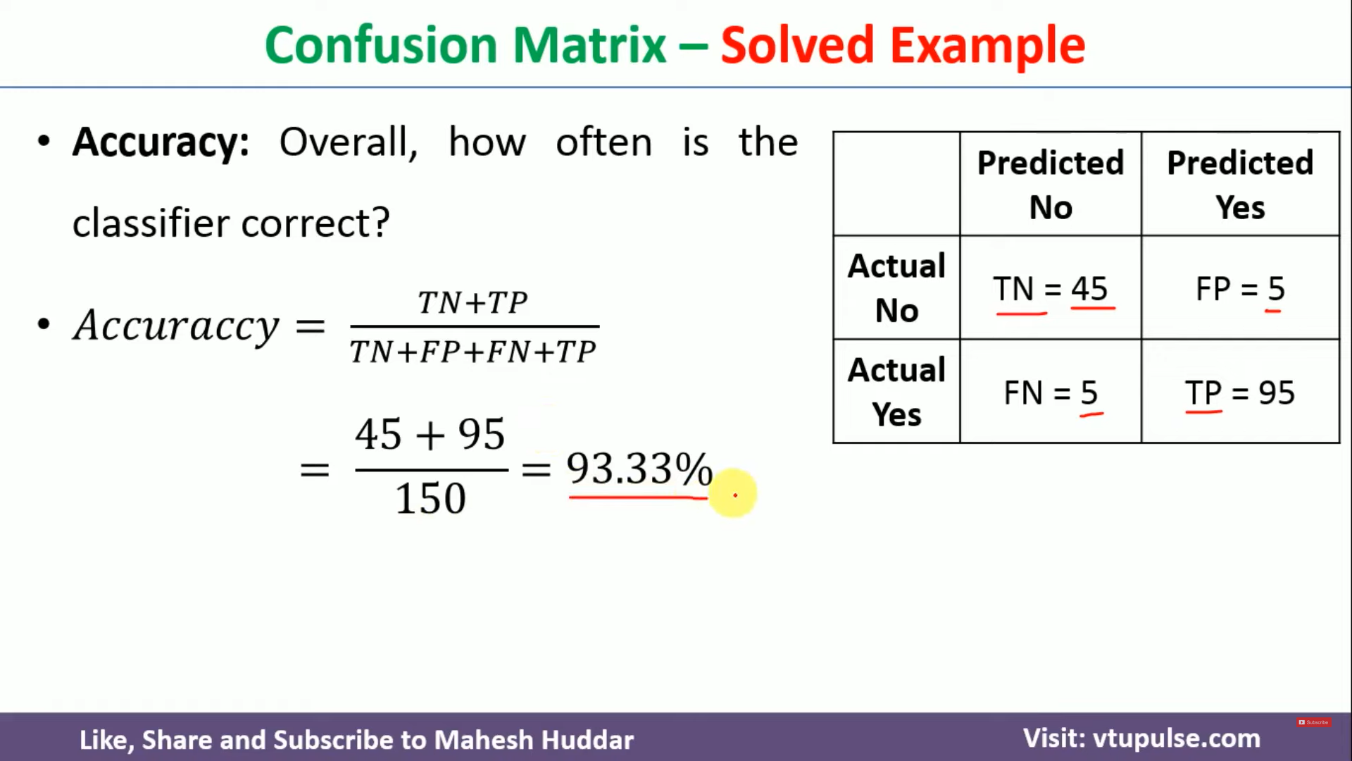
Accuracy:
Accuracy measures the percentage of correctly classified instances out of all instances.
Here Accuracy of the model is 99.33%.
Recall:
Recall measures the proportion of true positive predictions out of all actual positive cases.
True positive rate = TP / Actual yes
= 95 / 100 = 95%

Precision:
Precision measures the proportion of true positive predictions out of all positive predictions.
Precision = TP / Predicted yes
= 95 / 100 = 95%

F1 Score:
The F1 score is the harmonic mean of precision and recall.

- Decision Tree Algorithm - supervised learning algorithm

Decision tree is a tree-like structure where each branch corresponds to attribute value and each leaf node represents the final decision or prediction.
Decision tree algorithm can be used to solve both regression and classification problems.

Example of Decision Tree
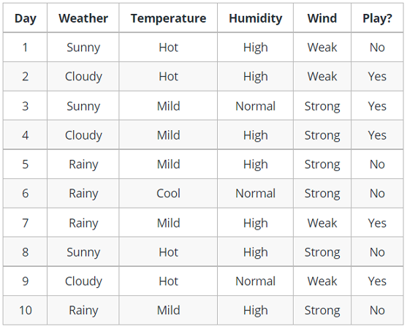

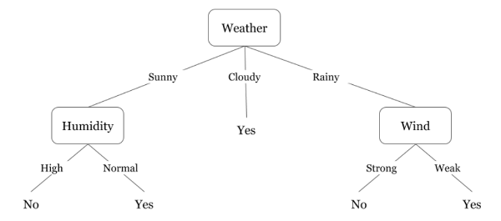

The identification of the attribute for the root node at each level is known as attribute selection.
- Entropy
- Information Gain
- Gini Index

Entropy : is the amount of uncertainty in the dataset

Entropy is nothing but the uncertainty in our dataset or measure of disorder.

The formula for Entropy:

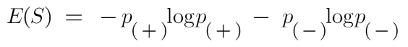
Here,
S is the subset of the training example
p+ is the probability of positive class.
p– is the probability of negative class.

Suppose a feature has 8 “yes” and 4 “no” initially.
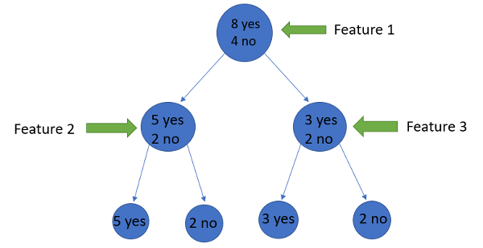

To check the impurity of feature 2 and feature 3 we will take the help for Entropy formula.
E(feature 2) =
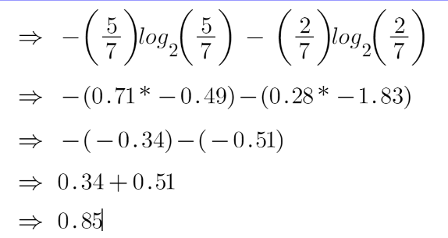
E(feature 3) =
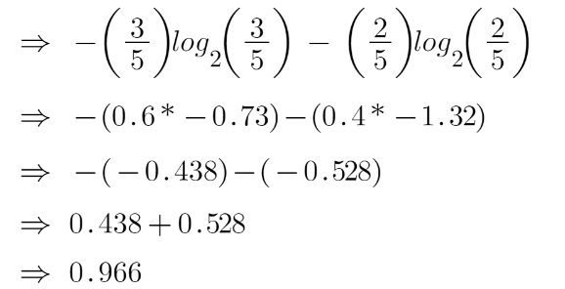

Hence, left node has low entropy or more purity than right node.

Information Gain :

Information gain measures the reduction of uncertainty given some feature and it is also a deciding factor for which attribute should be selected as a decision node or root node.

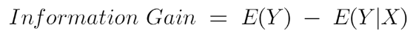

It is just entropy of the full dataset – entropy of the dataset given some feature.

Suppose our entire population has a total of 30 instances. The dataset is to predict whether the person will go to the gym or not.

Feature 1 is “Energy" : "High" and "Low"

Feature 2 is “Motivation” : “No motivation”, “Neutral” and “Highly motivated”.

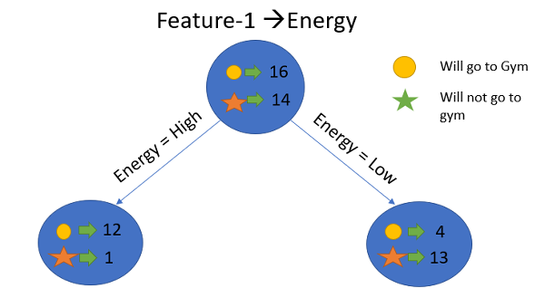
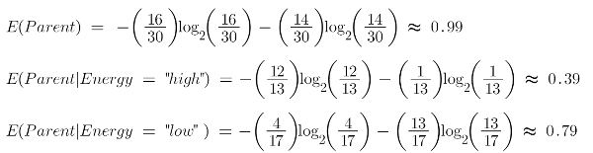
To see the weighted average of entropy of each node we will do as follows:
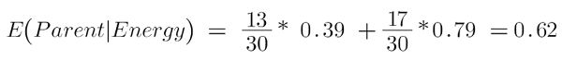
Now information gain will be:
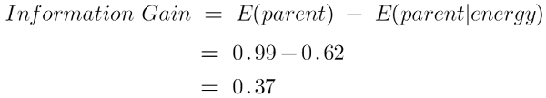
Our parent entropy was near 0.99 and after looking at this value of information gain, we can say that the entropy of the dataset will decrease by 0.37 if we make “Energy” as our root node.

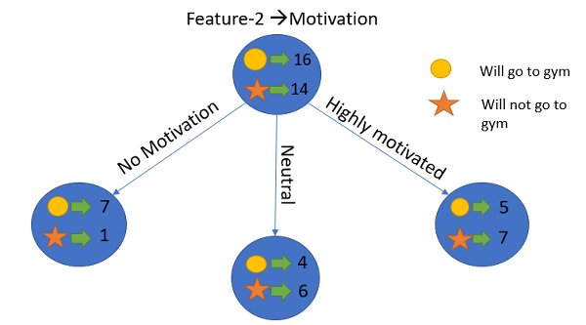

Let’s calculate the entropy here:
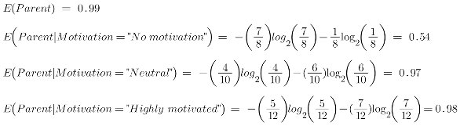
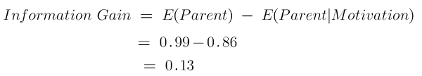
“Energy” feature gives more reduction which is 0.37 than the “Motivation” feature. Hence, we will select the feature(Energy) which has the highest information gain and then split the node based on that feature.

When to Stop Splitting?

through hyperparameter tuning
We can set the maximum depth of our decision tree using the max_depth parameter.
Another way is to set the minimum number of samples for each spilt. It is denoted by min_samples_split.

4 types of decision tree:
- Classification tree,
- Regression tree
- Cost-complexity pruning tree
- Reduced Error Pruning tree

Unsupervised Machine Learning:

Unsupervised machine learning uses machine learning algorithms to analyze and cluster unlabeled datasets. These algorithms discover hidden patterns or data groupings without the need for human intervention.
These models automatically find patterns in data and group them together.
customer segmentation, and image recognition.

K means Clustering –
K-Means Clustering is an Unsupervised Machine Learning algorithm, which groups the unlabeled dataset into different clusters.
Clustering is the process of dividing the entire data into groups (also known as clusters) based on the patterns in the data.

Example:
A bank wants to give credit card offers to its customers. Currently, they look at the details of each customer and, based on this information, decide which offer should be given to which customer. One option is to segment its customers into different groups.
The bank can group the customers based on their income:

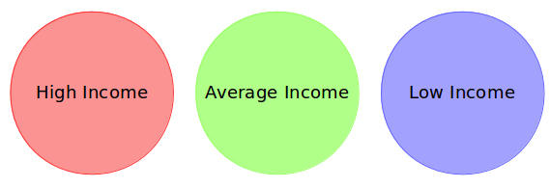
The groups I have shown above are known as clusters, and the process of creating these groups is known as clustering.

Properties of Clusters

All the data points in a cluster should be similar to each other.

The data points from different clusters should be as different as possible.

let’s say the bank only wants to use the income and debt to make the segmentation. They collected the customer data and used a scatter plot to visualize it.
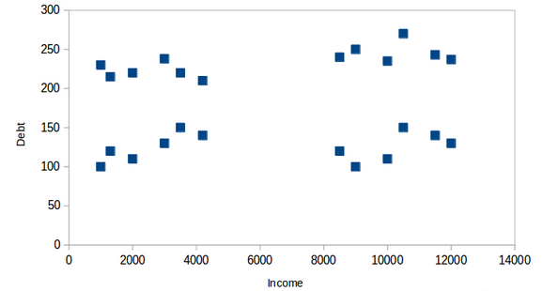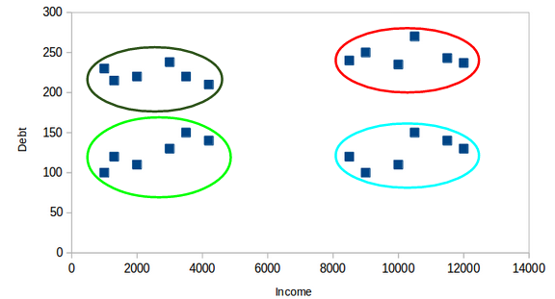
Here, we can clearly visualize that these customers can be segmented into 4 different clusters.

Inertia:
inertia calculates the sum of distances of all the points within a cluster from the centroid of that cluster.
the distance between them should be as low as possible.
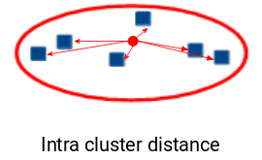

K-means clustering is now widely used in machine learning to partition data points into K clusters based on their similarity. The goal is to minimize the sum of squared distances between the data points and their corresponding cluster centroids, resulting in clusters that are internally homogeneous and distinct from each other.

The main objective of the K-Means algorithm is to minimize the sum of distances between the points and their respective cluster centroid.

How to Apply K-Means Clustering Algorithm?



1. Choose the number of clusters k :

2. Select k random points from the data as centroids.

Next, we randomly select the centroid for each cluster. Let’s say we want to have 2 clusters.

K = 2

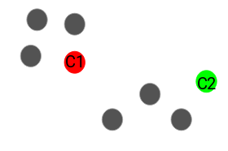

Assign all the points to the closest cluster centroid.

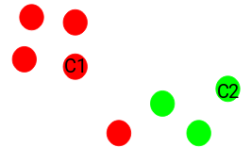

Recompute the centroids of newly formed clusters.

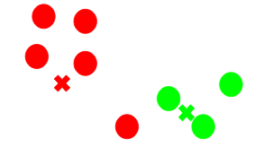

Repeat steps 3 and 4

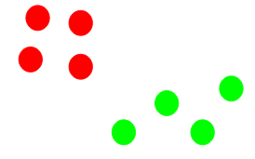

Stopping Criteria for K-Means Clustering
- Centroids of newly formed clusters do not change.
- Points remain in the same cluster.
- Maximum number of iterations is reached.
Elbow Method:
Elbow Method is used to decide the optimum number of clusters.
# Find optimum number of cluster
sse = [] #SUM OF SQUARED ERROR
for k in range(1,11):
km = KMeans(n_clusters=k, random_state=2)
km.fit(X)
sse.append(km.inertia_)

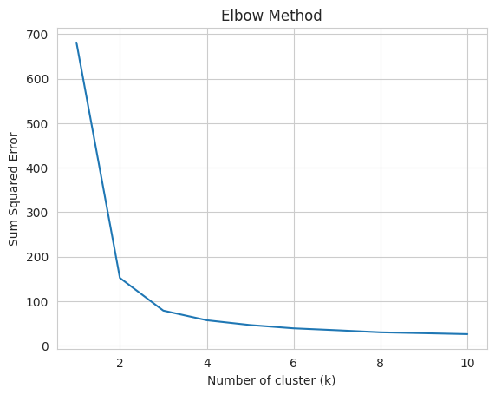
the cluster value where this decrease in inertia value becomes constant can be chosen as the right cluster value for our data.
So, we can consider K = 3

